DIGITAL MARKETING PROJECT

A project work by:

* Amit Kumar Singh (2020305001)
* Divya
* Logesh
* Devadarshini

--------------------------------------------------------------------------------------------------------------------------------------

## Brand Name Creation: Creating a brand name,

## Brand identity Design: Designing a brand logo - using Canva and

## Creating an email account on Gmail to link all your project work

## **Brand Name Creation: Creating a brand name**

#### Brand Name: The Nomads Email: gennextclothing@gmail.com

#### Category: Travel company Logo Theme : Related travel Company

#### Target Audience: Travellers

**Brand identity Design: Designing a brand logo - using Canva.**

Step 1: Opening Canva

we opened the Canva software on our desktop.

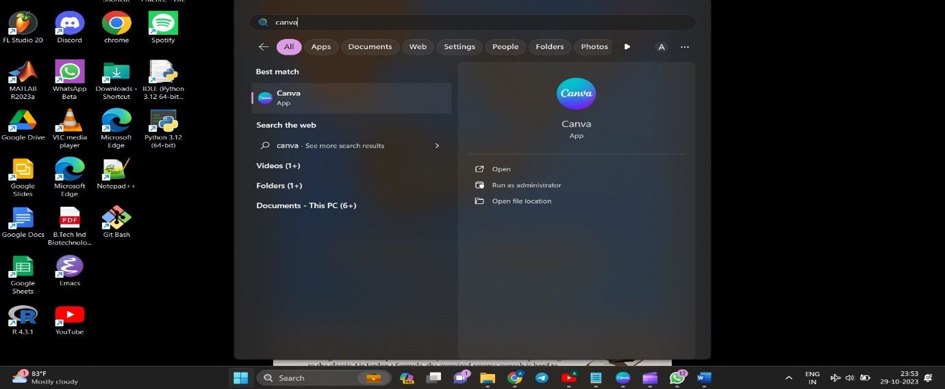

Step 2: Create a design.

We selected ‘create a design’ tab chose ‘logo’ and pressed enter. since we had to design a logo we chose logo but there are multiple task which we can perform.

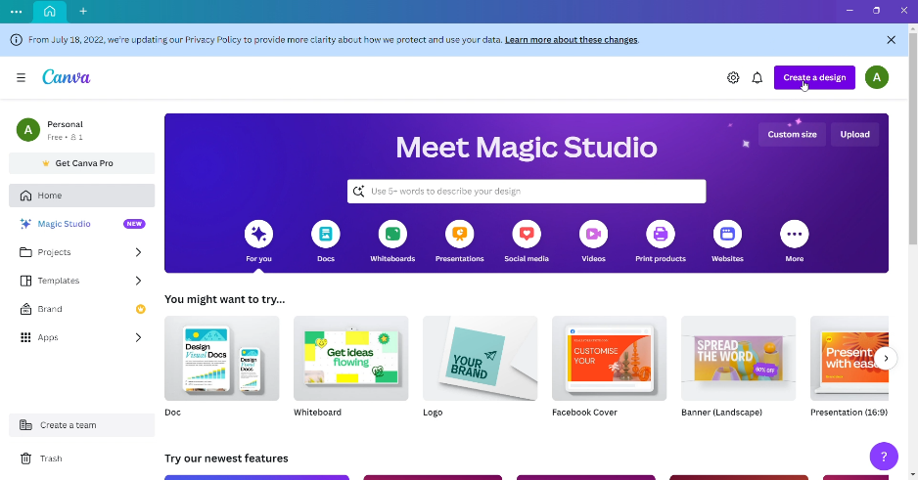

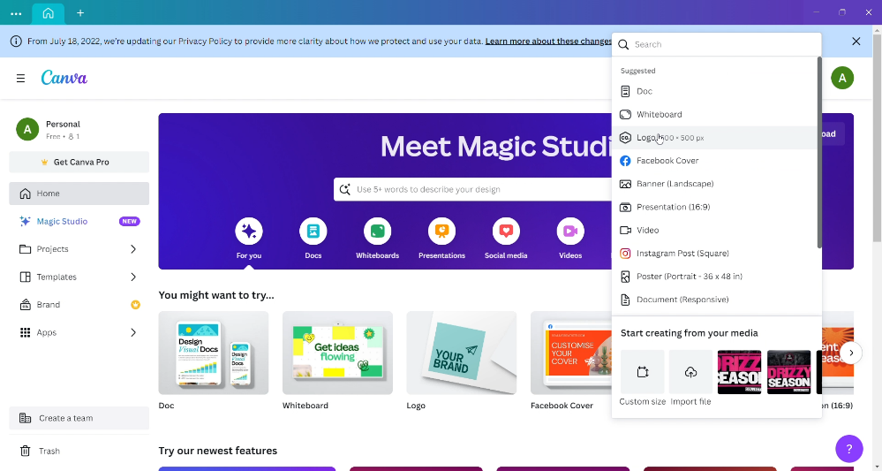

Step 3: ‘Naming the project’.

we named our project as ‘TheNomad’ by clicking at the untitled box at upper right corner of the page.

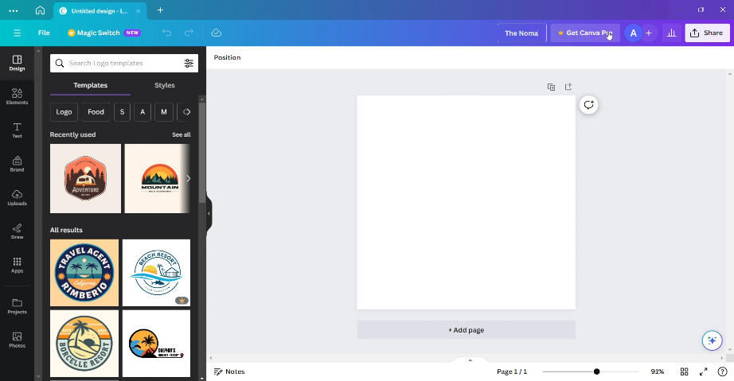



Step 4: Selecting a Template.

We selected a template by clicking at template section. Since we wanted to design a logo for a travel company, we wrote travel in the template search bar and pressed enter which returned us 1000’s of templates related to that. we chose one of the templates which was free to use. We chose our template of interest and dragged it using cursor to the workspace.



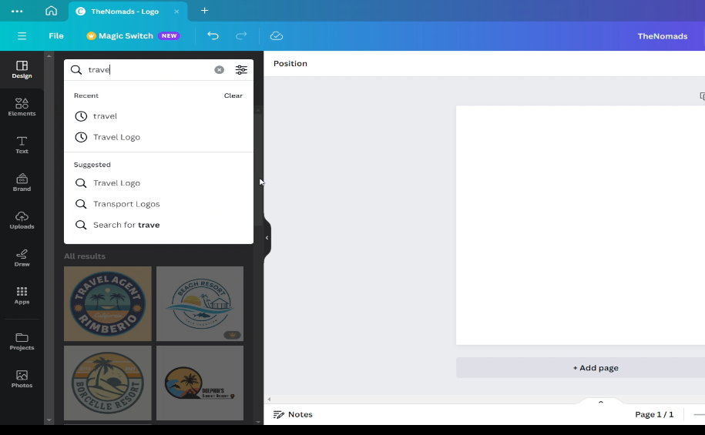

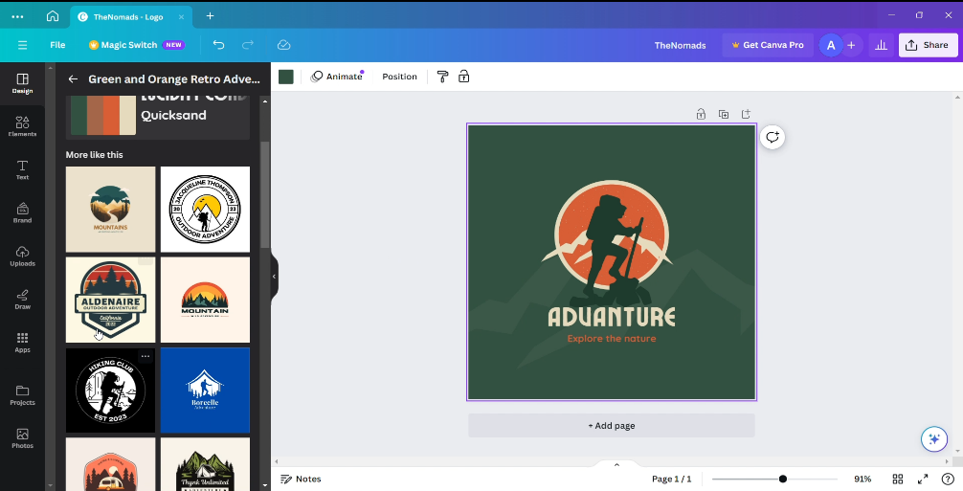

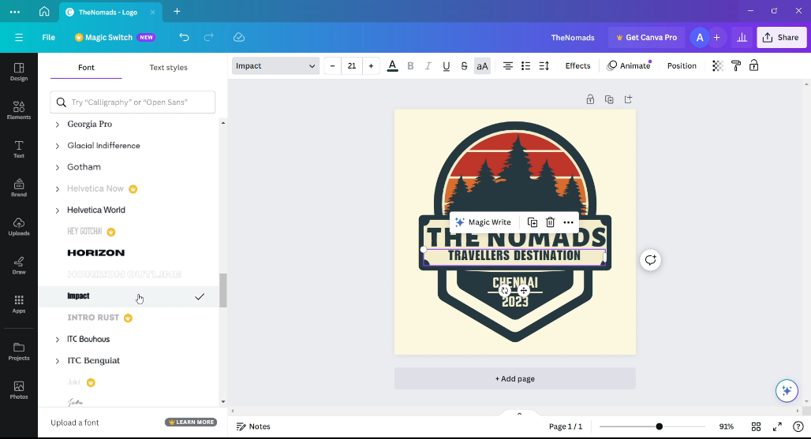Step 5: Editing t